Hem of Your Garment. Album Prolonging the Magic.
Original in C, perform in Fm = +5 semitones
Casio CTK3k Bank 1 Reg 3
#253 Trumpet, #012 Honky Tonk Piano for acapella part
#342 PopPlk1 for chorus clicking, 472 for ChoralAh’s in chorus
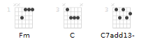
Brad set aside guitar?
Thematically sensible for thank-you’s.
Clap on one beats.
Vibra-slap one one-beats
Chip starts with wok-a-wok

[Verse 1] megaphone effect
(all right) I am intrinsically no good Fm Fm
I have a heart that's made of wood C over G to C7 over Ab C-C7add13
And I am only biding time or: C/F-E/G-E-Ab like guitar Fm
Only reciting memorized lines C-C7add13
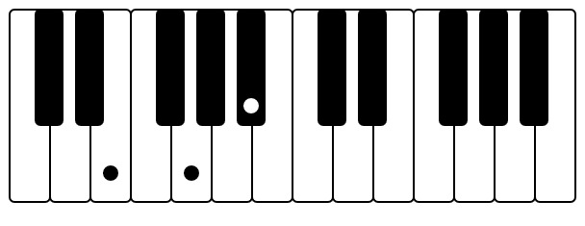Backup vox 1st note G. #253 or #472
[Chorus 1]
And I'm not fit to touch [double]
The hem of your garment, oh, no, no G/C-E/G...C/E-G/C
C 2nd inv-C 1st inv...C7-C chord
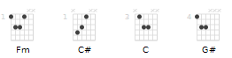
(ah ah) [Bye Bye Birdie] Unision: E-C-G-E, 3rd: G-E-Bb-G
I'm not fit to touch [double]
The hem of your garment, oh, yeah, yeah
C 2nd inv-C 1st inv...C chord-C aug
(ah ah) Unison: E-C-G-G# 3rd: G-E-Bb-C

[Bridge 1] shaker or cabasa.
piano Fm, Bb, Em, Ab
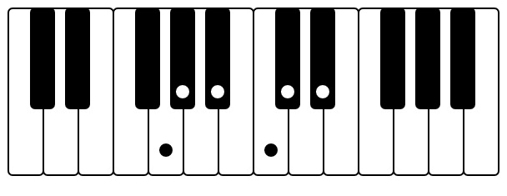Horn lick 1, 1st note C#. #253
root bass notes: Fm-C#-C-G#
[horn solo on guitar, 4 bars (Marc)]
C#-C...D#-C#-C-Bb...G#-G-G#-Bb-C...Bb-G#-G

[Verse 2]
I have no love, but only goals
How very empty is my soul
It is a soul that feels no thrill
It is a soul that could easily kill

[Chorus 2] computer clicks

[Bridge 2] shaker or cabasa
[horn solo on guitar, 4 bars (Marc? Brad keys?)] G-G#-F...C-C#-Bb-G#-Bb-C-C#-Bb
piano chords: Fm (F,A♭,C)...Bbm, 2nd inv. (F,B♭,D♭)...Edim (E,G,B♭)...A♭ 2nd inv. (E♭,A♭,C)
= minor 1, minor 4, minor 7dim, major flat 3
[guitar solo over trumpet riff, 4 bars (Marc)] while Brad keeps trumpet going on MELODICA
whip sound
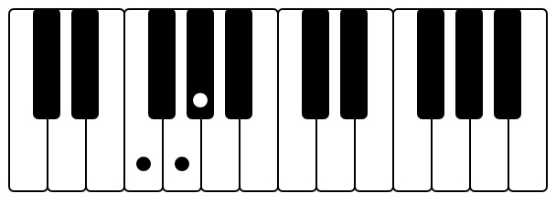Horn lick 2.1, 1st note G. #253
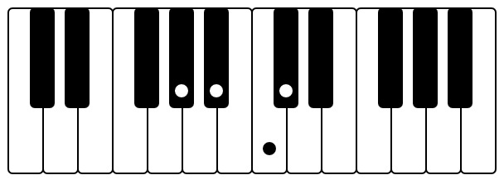Horn lick 2.2, 1st note C. #253

[Verse 3 = Verse 1]

[Chorus 3]
[Chorus 4 A cappella with bass first half] G#-F
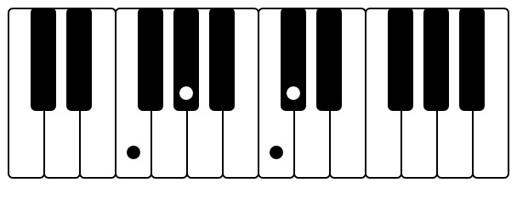Piano 1.1, 1st note Fm. #012
Piano right F-G#-C--F-G#-C--F-G#-C--F-G#-C--F-G#-C
Piano left C#-C-G#-F
or F-D#-C#-C-A#-G#
Piano right E-G-Bb—E-G-Bb—E-G-Bb--- E-G-Bb--E- G- Bb--
Piano left C- Bb-G#-F
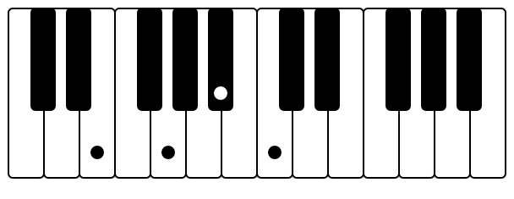Piano 1.2, 1st note Em. #012
or C-A#-G#-G- F- E
Or one hand: F-G#-C...C#-C-Bb-Ab...E-G-Bb...C-Bb-Ab-G
[Bridge out]
[trumpet riff, 4 bars (Marc? Brad keys?)]
[guitar solo over trumpet riff, 4 bars (Marc?)] while Brad keeps trumpet going on MELODICA
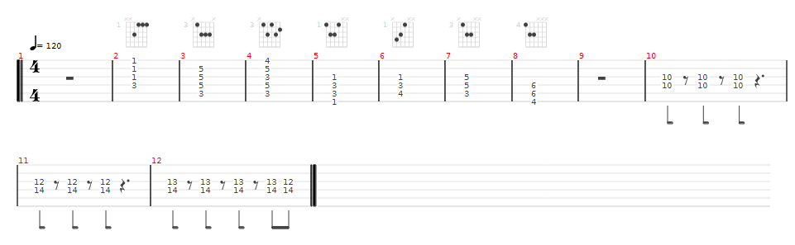

Piano, while singing
intro: C/F, E/G, E/Ab
verse: F, G, Ab
chorus: Fm over F, C over C, C7 over Ab
bridge: Fm, C7


