Dime. Pressure Chief. John McCrea
Original in G, play in A (=+2 semitones) 114bpm
Casio ctx3k: 387 or 398 intro, 027 arpeggiated #004, 231 verse 2

[Verse 1]
In the brown shag carpet of a cheap motel I A
synth: 1-3-5-7-8-(7-8)=A-C#-E-G#-A-(G#-E)
In the dark and dusty corner by the TV shelf I...IV....(iii) A...D...(C#m)
synth: 1-3-5-7-8 in the 4th: D (I/iii) (B/D#)or(D#m)
synth: 7-3-5-7-8-7-6 in the 4th: D
Is a small reminder of a simpler time ii...(I) Bm...(A)
synth: 1-b3-5-b7-8 in the 2nd: B
synth: 1-3-5-8-7-6-5 in the root: A
When a crumpled up pair of trousers V E
lost a brand new dime V...(IV)...I E...(D)...A
synth: G#-A-B-C#-D-E-F3-G# = 3-4-5-6-b7-8-9-10 in the 5th: E
synth: 1-3-5-7-8-(7-8)=A-C#-E-G#-A-(G#-E)

[Verse 2] no synth first 2 lines
Well you ask me how I made it through I A
and how my mint condition could belong to you I...IV D
synth licks + arpeggiator (I/iii) (G/B)or(Bm)
When I'm on the ground I roll through town ii Bm
I'm a president you don't remember getting V E
kicked around V...(IV)...I E...(D)...A

[Chorus 1] arpeggiator
I'm a dime, I'm fine IV...iii D...C#
1-3-5-7-8 in D, 1-3-5-7-8-7-8 in A
And I shine, I'm freshly minted ii...I B...A
1-3-5-b7-6-5-3 in E, 1-3-5-7-8-7-8 in A
I am determined, not to be dented
By a car or by a plane or anything not yet invented
[flange filtered arpeggio]
[2 bar guitar line, wood block quarter notes, shaker, synth]
A-B-C#-D...D-E-D-E-F#-G#-A...A-B-E-F#-G#-A...B-E-D-C#
A-B-C#-D...D-E-D-E-F#-G#-A...A-B-E-F#-G#-A...B-E-B-E-B
I'm a dime, I'm fine, and I shine
[1 empty bar then woka woka flams]

[Verse 3] no synth until very last bar
In the hiss and rumble of the freeway sounds
As the afternoon commuters drive their cars around
fiddle 231: F#...G-F#...G-F#--G-F#- E-D
There's a ringle jingle near the underpass
fiddle same
There's a sparkle near the fast food garbage and roadside trash
fiddle 231: E...F#-E...F#-E...F#-E-D-C#-B-(A+C#)

[Chorus 2] synth licks plus arpeggiator
I'm a dime, I'm fine D...A (1st inv=3-5-8-3)
1-3-5-7-8 in D, 1-3-5-7-8 in A
And I shine, I'm freshly minted E (2nd inv=5-8-3-5)...A
?1-3-5-b7-8 in E, ?1-3-5-7-8-7-6 in A
I'm silver-plated, I'm underrated
You won't even pick me up because I'm not enough for a local phone call
[flange filtered arpeggio]
[2 bar guitar line, wood block quarter notes, shaker, synth]
I'm a dime, I'm fine, and I shine
I'm a dime, I'm fine, and I shine
I'm a dime, I'm fine, and I shine

Outro 1x empty 4x after woka woka flams

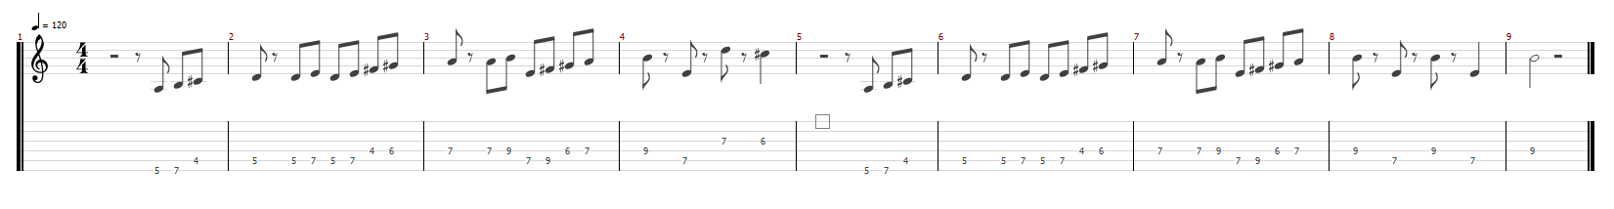Two-bar guitar line

