Sheep Go to Heaven, Goats go to Hell. Prolonging the Magic album.

Single charted at #16. Original in A, play in D =+5 semitones.
#279 Mute Trumpet

Intro + V1 drums: stripped down AC/DC.
Marc do the Rockford Files notes under Brad soloing the trumpet part
2025-06-03 Drop the “singalong with us” intro for the time being

[Verse 1] arena rock feel Backup vox 1 Backup vox 2
I'm not feeling alright today Double Octave up and/or down
I'm not feeling that great Double Octave up and/or down
I'm not catching on fire today Double Octave up and/or down
Love has started to fade - -
I'm not going to smile today - -
I'm not gonna laugh 4th 6th and/or double
You're out living it up today -
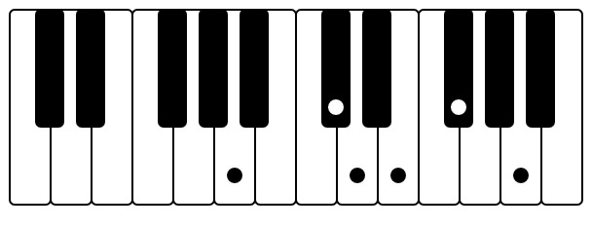
I've got dues to pay Forceful double/talk piano 001 or glockenspiel 414
[Pre-Chorus]
And the grave-digger puts on the forceps -
The stonemason does all the work Double
The barber can give you a haircut “cut” higher A/C#-C#/E...D/F# -F#/A/C
The carpenter can take you out to lunch “lunch” 4th “lunch” 6th or A/C#-G/C#....F#/D-F#/C
Now, but I just want to play on my pan-pipes -
I just want to drink me some wine -
As soon as you're born you start dyin' “dying” 4th “dying” 6th A/C#-C#/E...D/F# -F#/A
So you might as well have a good time, oh no -
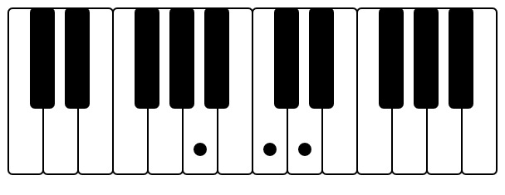
trumpet 253
[Chorus] siren. trumpet: A-C-D...A-C-D-D-D-C-A....A-C-D...A-C-D-C-A-G-A
Sheep go to Heaven, goats go to Hell Double Octave up and/or down
Sheep go to Heaven, goats go to Hell Octave up+down Double
Oh no, ah yeah, alright, Yeah, ho!, Nah, nah, ya
Intro drums: stripped down AC/DC
Marc do the Rockford Files notes under Brad soloing the trumpet part
[Verse 2] backups are 4th? harmonies arena rock feel
I don't wanna go to Sunset Strip - Octave down
I don't wanna feel the emptiness 4th -
Bold marquees with stupid band names 4th -
I don't wanna go to Sunset Strip - -
I don't wanna go to Sunset Strip - Octave up
I don't wanna feel the emptiness 4th Octave up
Bold marquees with stupid band names 4th Octave up
I don't wanna go to Sunset Strip - -

[Instrumental Break: 5 phrases in D] [Interlude] (Hey! Two, three, four!) (Hey!)
1. bass descending arpeggio: 8-7b-5-4-3-1-7b-1

2. add a first vocal “na” that mirrors #1 + guitar same part
3. add a second vocal “na” that mirrors #1
add first guitar minor descender: 8-7b-6b-5
4. add a third vocal “ah” that mirrors #3
add second guitar that hits the 8+ on minor descending notes
5. add siren
Alternative:
1. Rodney bass line
2. add Brad guitar mirroring bass line
3. add Marc with guitar variation
4. switch Brad on guitar to:
live horn part variation: https://www.youtube.com/watch?v=DokYbnWz2Uk&t=2955s
D...A...D-G....C-B-G-B-Bb
5. switch Brad to siren or guitar bar chords
D-E#-G-A#C#
[Pre-Chorus]
[Chorus] All right, Oh no, oh no
[Chorus] 2 horn licks A-C-D, A-C-D. A-C-D-C-A-G#-A
Intro guitar 1

Intro guitar 2

Instrumental break descending arpeggio

