Opera Singer, on CAKE’s fourth studio album, platinum-certified Comfort Eagle

Original: starts in B, root E. CAKEMIX: start in E, root A.
Casio CTX3k #1-3 (087 Rock Organ, 68G4, 263 Brass Fall)

2 bar drums (8 count) Rodney electronic hi hats? clap? Marc finger slap all strings/high E 16th clicks
Rodney 16th claps and syncopated whistle; Marc syncopated 1-3-5 thing
4 bar drums + guitar lick (same as trumpet fanfare) + hit high E chord each first two (Brad)
1 bar drums + guitar descend riff (Marc) + bass walk
1 bar drums + guitar descend riff (Marc) + bass walk + trumpet fanfare (Brad)
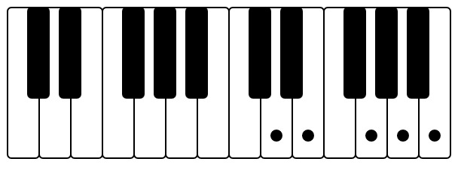First note: E Trumpet fanfare 253

[Verse 1] Brad do finger slap to get 16th clicks (2025-08-06 what is this?)
I am an opera singer [double, spot on and smooth] A → Amaj7
I stand on painted tape A7/E → D
It tells me where I'm going D → E
And where to throw my cape E → D
Brad do string hits or claps
[Verse 2] [hammond organ see tabs]
I call my co-stars "brother"
I call my co-stars "knave"
I play both good and evil parts
I sing to Verdi's grave A-B-C#-B-A guitar lick (Marc) plus high A syncopated (Brad)
[Verse 3] Brad direct audience to small clap
And every single morning
By 10 AM I'm dressed
My rehearsals last for hours and hours
With diligence I have been blessed
[Verse 4]
Some people, they call me monster [hammond organ see tabs] + [chicken pickin’ see tabs]
Some people, they call me saint
My talent feeds my darker side
Yet no one will com...plain A-B-C#-B-A guitar lick (Marc)
[Chorus 1] jumpjack hand claps. bass play root notes instead of walks. quarter hats. arena rock feel.
I am an opera [double] singer [Brad D, 3rd=F#, 5th=A] E (Brad) + chorus guitar melody (Marc)
another harmony: E-D#-C#-B-A-G#-E (see https://www.youtube.com/watch?v=DokYbnWz2Uk&t=972s)
I sing in foreign lands D → A + high trumpet trill (Marc, see tabs)
I've sung for kings in [double] Europe [Brad D, 3rd=F#, 5th=A] E
And emperors in Japan [Brad D, 3rd=F#] D → A + high trumpet trill (Marc, see tabs)

4 bar with walking bass + mellow ascending trumpet lick 2x (Brad)
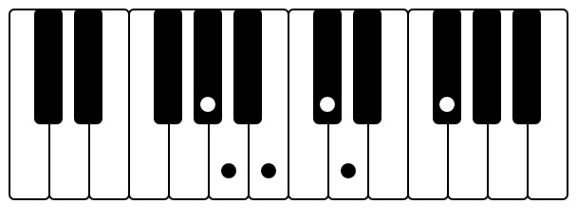#2 Mellow trumpet 253
2 bar with walking bass + guitar descending riff 1x
2 bar with walking bass + guitar descending riff 1x + trumpet fanfare 1x

[Verse 5]
And after each performance
People stand around and wait
Just to tell me that they love my voice
Just to tell me that I'm great guitar phrase ends on B=2nd string; 14-12-14-15-14

[Verse 6] Brad direct audience to small clap,
I am an opera singer [double]
I will sing when you're all dead [double]
I sing the mountains [Brad D, 3rd=F#, 5th=A] crumbling apart [double]
I sing what can't be....said [Rodney double] A-B-C#-B-A guitar lick (Marc)

[Chorus 2] hand claps. bass play root notes instead of walks. quarter hats. arena rock feel.
I am an opera [double] singer [Brad D, 3rd=F#, 5th=A] E
I sing in foreign lands [Brad D, 3rd=F#] D → A +[high trumpet trill see tabs]
Most people seem to know [double] my name [Brad D, 3rd=F#, 5th=A] E
Or at least know who I am [Brad D, 3rd=F#] D → A+ [high trumpet trill]

2 bars bass riff + robot + no hi hats (Brad cabasa?)
2 bars bass riff + robot + hi hats
4 bars bass riff + robot + hi hats + guitar descend riff 2x
4 bars bass riff + robot + hi hats + guitar descend riff 2x + high trumpet fanfare 2x

[intro guitar descender riff]
[verse main guitar part]
[verse hammond organ part]
[verse chicken pickin’ part]
[chorus guitar melody]
[chorus high trumpet trill]
[intro mellow ascending trumpet lick]
[intro high trumpet fanfare, same as intro guitar lick]

Below: intro horn licks on guitar:
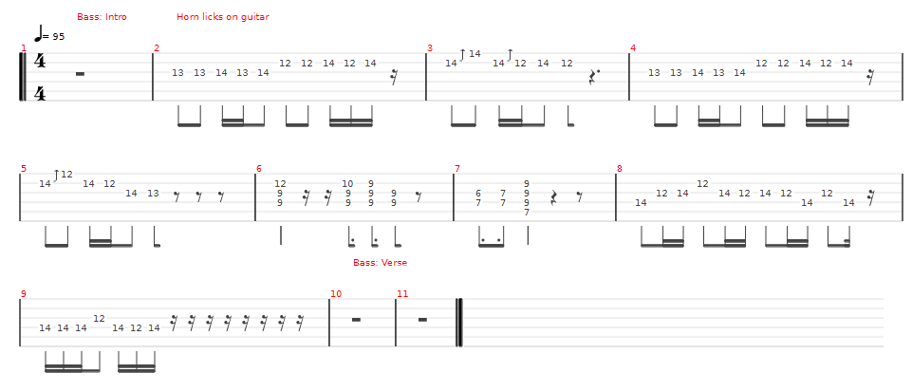
Below: guitar playing the intro horn licksBelow: bass lines

Below: bass lines


